District: Honolulu District, Pacific Ocean Division
Initiative Title: Hawaii Regional Sediment Management – West Maui Region
District POC: Lorayne P. Shimabuku, CEPOH-PP-C, RSM Project Manager
MSC RSM POC: David Lau and Helen Stupplebeen, RSM POC, CEPOD-PDC
Technical POC: Thomas D. Smith, CEPOH-EC-T
Financial POC: Joanne Hasegawa, CEPOH-PP-PC

Bottom Line up Front (BLUF): The West Maui Region incorporates a thin coastal margin backed by steep mountainous terrain that has been vastly altered by agricultural and urban development. Increased siltation within nearshore waters associated with loss of forest land, historical agriculture practices, stream channelization, and rapid development has impacted coral reef health. Shoreline erosion threatens upland development consisting of large-scale resorts, hotels, condominiums and single-family homes. Shoreline hardening is being proposed along a number of parcels and the Hawaii Regional Sediment Management (RSM) non-federal sponsor the Hawaii Department of Land and Natural Resources (as well as the County of Maui) is looking for more natural solutions to the problem. The federally authorized West Maui “Ridge to Reef” Initiative (see Figure 1) will engage various federal, state and county agencies in the implementation of a strategy to reduce the threats of land-based pollution to coral reefs in West Maui. The U.S. Army Corps of Engineers’ (USACE) hopper dredge Essayons is scheduled to conduct Operation & Maintenance (O&M) dredging of five Honolulu District deep draft harbors in FY15. The work will reestablish authorized project depths at Kahului, Barbers Point, Honolulu, Hilo and Nawiliwili harbors. The West Maui RSM effort would focus on reducing siltation of nearshore waters, identifying potential offshore sand sources, mapping benthic habitat groundtruthing remote sensing data and beneficial use of dredged material from Kahului Harbor.
Coastal, airborne LiDAR and imagery collected by the Joint Airborne LiDAR Bathymetry Technical Center of Expertise (JABLTCX) for the USACE National Coastal Mapping Program are used to develop a standard suite of mapping products on a recurring basis. Airborne surveys collect high resolution bathymetric and topographic data and hyperspectral and aerial imagery along a 1-mile swath of the coast, including offshore and onshore portions of the coastal zone. For this study, data products for the offshore portion of the coastal zone, including bathymetric digital elevation models, aerial photo mosaics, hyperspectral image mosaics, and laser reflectance images will be further analyzed to characterize the seafloor and assess volume changes for multi-temporal datasets where available. Fusion of bathymetry and hyperspectral imagery will be conducted to create enhanced seafloor data products in which major bottom (benthic) types can be identified through standard remote sensing classification procedures. The enhanced data are useful for a variety of regional sediment management objectives, such as distinguishing sand fields from hard bottoms to aid in the management of dredged material and locating potential sites for sediment sources and disposal areas. More importantly, data fusion methods to develop enhanced seafloor data products will be streamlined and standardized, ensuring their transferability to other coastal areas.
1) Background: Honolulu District’s overall RSM plan is to investigate RSM opportunities along all shoreline regions in Hawaii. To date, Hawaii RSM has been instrumental in quantifying coastal processes and identifying sediment related issues in various regions of Oahu (Mokapu Point to Makapuu Point, Diamond Head to Pearl Harbor and the Haleiwa Region),
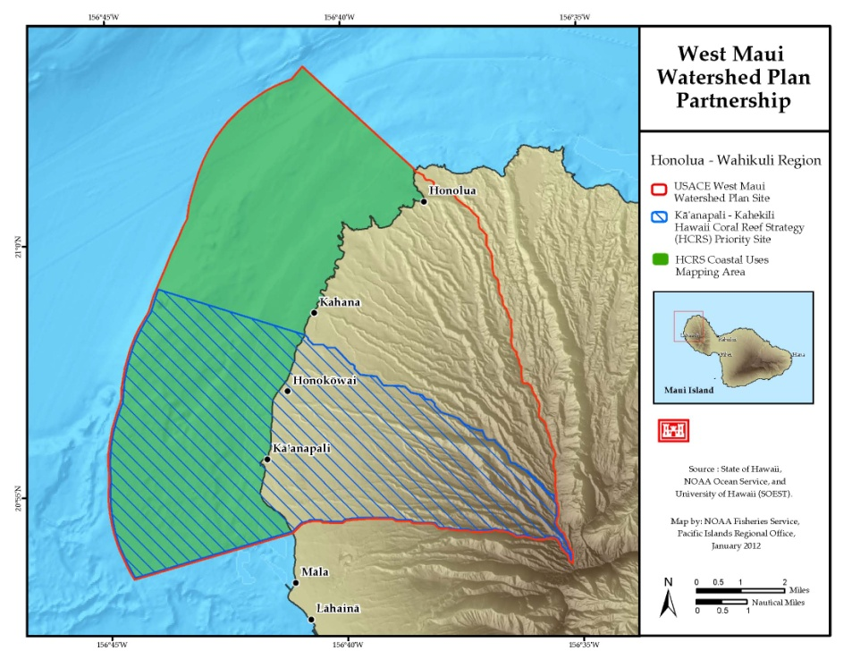
Figure 1. Location map of the West Maui RSM Region which coincides with the limits of Honolulu District’s West Maui “Ridge to Reef” Initiative.

Kauai (Poipu and Kekaha) and Maui (Kahului and Kihei). The following proposed FY14 tasks provide for initiation of RSM activities in West Maui.
In September 2012, the Department of Land and Natural Resources (DLNR) and the U.S. Army Corps of Engineers, Honolulu District signed a $3 million cost-share agreement to develop a watershed plan to support the West Maui “Ridge to Reef” (R2R) Initiative. The Initiative is one of the first efforts in the state to implement a comprehensive management strategy to address impacts to coral reefs across multiple watersheds. West Maui has some of the most severely impacted coral reefs in the state. Causes of coral reef decline are complex and not yet fully understood. However, land-based pollution is known to be a serious threat to coral reef ecosystems. Increased sedimentation associated with loss of forest land, historical agriculture practices, stream channelization, and rapid development has clearly impacted coral reef health. The West Maui R2R Initiative will engage various federal and state agencies and organizations in the implementation of a strategy to reduce the threats of land-based pollution to coral reefs in West Maui.
The proposed West Maui RSM Region tasks will identify offshore sand sources and benthic habitat through the processing of LiDAR data collected in 2000 and in the coming months during 2013 by the JALBTCX. Changes in bathymetry and benthic habitat will also be quantified through use of the LiDAR data. Inland sediment management issues will be investigated to determine specific sources of material and potential remediation measures. Application of Engineering with Nature (EWN) techniques to reduce siltation of nearshore waters will also be considered. Typical RSM tasks including a shoreline change analysis, coastal processes modeling, development of a regional sediment budget and various workshop activities will also be conducted for the West Maui RSM Region.
The USACE hopper dredge Essayons is scheduled to conduct O&M dredging at five Honolulu District deep draft harbors in FY15 (Kahului, Barbers Point, Honolulu, Hilo and Nawiliwili). A total of 300,000 cubic yards is estimated to be dredged (of which 100,000 cubic yards is estimated to be dredged at Kahului Harbor). The Essayons does not currently have a pump out capability and dredged material cannot be extracted from the hopper for reuse. Therefore, the dredged material may be destined for disposal in Environmental Protection Agency’s Offshore Dredge Material Disposal Sites (rather than keeping the material in the system, beneficially placing the material to reduce shoreline erosion, create environmental habitat, etc). The Honolulu District is investigating RSM opportunities to beneficially reuse the material. One task associated with this FY14 RSM proposal includes initiating coordination of beneficial use options for the material to be dredged from Kahului Harbor in FY15.
2) Regional Framework: Shoreline erosion is currently threatening upland development within a number of sub-cells in the West Maui Region. Condominiums, roadways, and critical infrastructure (built 30 to 50 years ago) are experiencing significant damages during storm events. Individual permits are being submitted for construction of seawalls (and other shoreline hardening structures) as small-scale emergency measures to reduce coastal storm damages. A regional framework will identify sand sources within the West Maui Region that can be used to provide shoreline stabilization solutions that preserve the coastal environment and sustain the region’s sense of place. The RSM tasks proposed for the region will also quantify existing benthic habitat coverage to enable avoidance of resources during future offshore sand recovery activities. Inland sediment management issues will be investigated utilizing EWN methods to reduce siltation of nearshore waters in coordination with the West Maui R2R Initiative.
3) Leveraging Opportunities: In a separate FY14 RSM proposal, the Jacksonville District, the Honolulu District and JABLTX propose to further the state-of-the-art of remote benthic mapping using LiDAR and Hyperspectral Imagery. Products will include maps of Hawaii (West Maui), Puerto Rico (San Juan Harbor), the United State Virgin Islands and Southeast Florida (Port of Miami). Products for the West Maui RSM effort will focus on identifying potential offshore sand sources, mapping benthic habitat and groundtruthing of the remote sensing analysis results. Products in Southeast Florida and Puerto Rico will help guide the deepening of the Port of Miami and San Juan Harbor, respectively. Products within the United State Virgin Islands will be used to preserve important environmental benthic habitat such as corals as projects develop in the islands.
4) Stakeholder Participation: The National Oceanic and Atmospheric Administration, the U.S. Department of Agriculture – Natural Resources Conservation Service, the U.S. Environmental Protection Agency, the National Fish and Wildlife Foundation, the State of Hawaii Department of Health, the West Maui Mountains Watershed Partnership, and Kaanapali Makai Watch are all providing assistance as part of the West Maui R2R Initiative to improve the health of West Maui’s reefs. RSM stakeholder participation will be encouraged through a workshop to determine RSM needs and opportunities within the region. The Hawaii RSM Project Delivery Team (PDT) will present study findings at the workshop and solicit stakeholder input on potential RSM investigations and projects for the region.
5) Accomplishments to Date: RSM investigations have been completed for the Mokapu Point to Makapuu Point, Diamond Head to Pearl Harbor and Haleiwa regions on Oahu, the Kahului and Kihei regions on Maui, and the Kekaha and Poipu regions on Kauai, and determination of RSM priorities for Hawaii. Technical notes for the Haleiwa Regional Sediment Budget and the Haleiwa Region Potential RSM Projects will be completed by the end of FY13.
6) Sediment Moved: RSM methodology has been shared extensively with local, state and federal agencies in Hawaii. RSM concepts have begun to be embraced and will result in ever increase volumes of sand being managed in Hawaii on a regional basis. A recent example of RSM in action was the dredging of approximately 100,000 cubic yards of beach quality sand from the Pearl Harbor entrance channel and its placement on the nearby beach at Iroquois Point in 2013. This constituted the largest single beach fill event in the history of the Hawaiian Islands.
7) Proposed FY14 Tasks:

Task 1:

Title: Shoreline Change Analysis (in-house effort)

Description: Shoreline change rates for the regions will be developed based on available T-sheets and aerial photography. Associated sediment pathways will be identified via numerical modeling coupled with the shoreline change analysis. Coastal process data requirements will also be compiled, including borrow area identification, beach profile data, dredging records and topographic/hydrographic LIDAR. Collaboration and Leveraging with USGS shoreline change experts.

Benefits: This task will help in developing the Regional Sediment Budget for the region.

Products: Maps and figures documenting shoreline rate changes and historical shorelines.

Task 2:

Title: Coastal Modeling (in-house effort)

Description: This task consists of using Wave Information Study hindcasts and Coastal Modeling System (CMS) numerical models (CMSflow and CMSwave) to determine water circulation and wave transformation characteristics for the region.

Benefits: Advancing the state-of-knowledge of regional coastal processes in Hawaii and improvement of sediment management in the West Maui Region. Coastal modeling data will be used to develop a conceptual regional sediment budget. Collaborating with ERDC’s Coastal Inlets Research Program.

Products: WIS and CMS will generate wave, water level, and water circulation predictions for the West Maui Region.

Task 3:

Title: Regional Sediment Budgets (in-house effort)

Description: Develop a conceptual sediment budget for the West Maui Region. This task will provide shoreline managers information they can use in prioritizing the use of limited sediment resources and allow local landowners to make decisions on practicable shoreline stabilization measures. Collaborating with ERDC’s Coastal Inlets Research Program.

Products: Technical note documenting the development and results of the regional sediment budget analysis utilizing SBAS.

Task 4:

Title: Identify Potential RSM Projects (in-house effort)

Description: All potential RSM project opportunities will be scoped to improve sediment management strategies in the region. Potential beneficial use of dredged material will be pursued in association with the scheduled FY15 O&M dredging of Kahului Harbor.

Benefits: Identification of potential RSM project within the West Maui Region will provide sustainable shoreline protection alternatives. Coordination for beneficial use options will be initiated in anticipation of FY15 O&M dredging at Kahului Harbor. Collaboration with JABLTCX; Participating Partners include Hawaii DLNR and the West Maui R2R Initiative stakeholders.

Products: A technical note will detail opportunities within the regions for potential RSM projects and potential uses for dredged material from navigation projects.

Task 5:

Title: Update Honolulu District RSM Web Site and Internet Mapping Service (in-house effort)

Description: The Honolulu District Regional Sediment Management web site and Internet Map Service (IMS) will be updated by posting of RSM information/activities, coastal process modeling results, shoreline change investigations and other study related data as it becomes available. Geospatial data products will be ported to the IMS for public dissemination and use.

Benefits: This task will enable uploading of current Hawaii RSM information to the web site and real-time availability of geospatial data products for public dissemination and use.

Products: The Honolulu District RSM web site and IMP will be updated to include newly available RSM information for the West Maui Region.

Task 6:

Title: West Maui Region Workshop (in-house effort)

Description: Conduct a workshop in the region concerning RSM needs and opportunities. The PDT will present RSM goals and strategies at the workshop and solicit stakeholder input on potential RSM investigations and projects for the region. Collaborating with Maui County and Hawaii DLNR, Participating Partners include Hawaii DLNR, Maui County and the West Maui R2R Initiative stakeholders.

Benefits: This effort would solicit stakeholder input on potential RSM investigations and projects for the region.

Products: Workshop documentation summarizing the needs, finding, and RSM opportunities discussed for the region.

Task 7:

Title: Attend FY14 National RSM Workshop (in-house effort)
Description: Funding will enable one Honolulu District RSM PDT members to prepare presentations and attend the FY14 national RSM workshop. The dates and location for the workshop are to be determined. Estimated costs are based on the workshop starting on a Tuesday and ending on a Thursday. Travel would consist of departing Honolulu on Sunday, arriving at the TDY location on Monday with the flight back to Honolulu on Friday. This would entail 4 days lodging and 5.5 days per diem. Flight costs are estimated at $1,500 with $200 for miscellaneous expenses. Total cost of this task is $10,000 ($3,000 travel and $7,000 labor).
Benefits: This task will enable sharing of successes and lessons learned with the RSM community. Honolulu District RSM POC will have the opportunity to learn from others’ experiences and network with the RSM community.

Products: One PDT member will prepare presentations and attend the FY14 national RSM workshop.

Task 8: NOTE: STILL LOOKING FOR A FUNDING SOURCE FOR THIS TASK.

Title: Prepare Enhanced Seafloor LiDAR Products (JABLTCX and in-house effort):

Description: Fusion of bathymetry and hyperspectral imagery will be conducted to create enhanced seafloor data products in which major bottom (benthic) types and bathymetric volume changes will be identified through standard remote sensing classification and differencing procedures.

Benefits: The enhanced seafloor data will facilitate a variety of RSM objectives, such as distinguishing sand fields from hard bottoms and quantifying volume changes between data sets to aid in the management of dredged material and locating potential sites for sediment sources and disposal areas. Remote sensing classification will quantify existing benthic habitat coverage and enable avoidance of resources during future offshore sand recovery activities. Collaboration with Jacksonville District and JABLTCX; Leveraging with NOAA on groundtruth; Participating Partners include NOAA, Hawaii DLNR and the West Maui R2R Initiative stakeholders.

Products: A technical note describing the geo-processing steps, software, and methods will be written as part of this task, and ultimately provide critical technical transfer for the development of enhanced seafloor products used for RSM.

8) Deliverables:

Deliverables: Date
Shoreline Change Analysis (Task 1) 7/30/14
Coastal Modeling (Task 2) 7/30/14
Regional Sediment Budgets TN (Task 3) 9/30/14
Potential RSM Projects TN (Task 4) 9/30/14
Update Hawaii RSM Web Site (Task 5) 9/30/14
West Maui Region Workshop (Task 6) TBD
Attend FY14 RSM Workshop (Task 7) TBD
Prepare Enhanced Seafloor LiDAR Products TN (Task 8) 9/30/14

9) Budget and Schedule*:

10) District RSM Team:

Name: Lorayne “Nani” P. Shimabuku
Office Symbol: CEPOH-PP-C
Title: Project Manager
Phone#: 808-835-4030
Email Address: lorayne.p.shimabuku@usace.army.mil

Name: Jessica H. Podoski
Office Symbol: CEPOH-EC-T
Title: Coastal Engineer
Phone#: 808-835-4146
Email Address: jessica.h.podoski@usace.army.mil

Name: Justin A. Goo
Office Symbol: CEPOH-EC-T
Title: Coastal Engineer
Phone#: 808-835-4150
Email Address: justin.a.goo@usace.army.mil

11) Technical and Financial Points of Contact:

Technical POC:
Name: Thomas D. Smith
Office Symbol: CEPOH-EC-T
Title: Coastal Engineer
Phone#: 808-835-4141
Email Address: thomas.d.smith@usace.army.mil

Financial POC:
Name: Joanne M. Hasegawa
Office Symbol: CEPOH-PP-P
Title: Program Analyst
Phone#: 808-835-4042
Email Address: joanne.m.hasegawa@usace.army.mil

